He’s Got the While World in His Hands

He’s got the whole world in His hands,
He’s got the while world in His hands,
He’s got the whole world in His hands,
He’s got the while world in His hands.

He’s got the ….. in His hands
….Wind and the rain
…. Little bitty baby
…. You and me brother
…. You and me sister
…. Sopranos and altos!

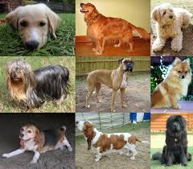

B-I-N-G-O

There was a farmer had a dog, and “Bingo” was his name-o!
B-I-N-G-O,
B-I-N-G-O,
B-I-N-G-O,
And “Bingo” was his name-o!

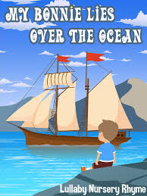
My Bonnie Lies Over the Ocean

My bonnie lies over the ocean;
My bonnie lies over the sea;
My bonnie lies over the ocean;
Oh, bring back my bonnie to me!

Bring back, bring back, oh, bring back my bonnie to me, to me!
Bring back, bring back, oh, bring back my bonnie to me!

O, blow ye winds over the ocean,
O, blow ye winds over the sea,
O, blow ye winds over the ocean,
And bring back my bonnie to me!

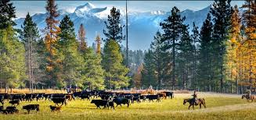
Home on the Range

O, give me a home where the buffalo roam, where the deer and the antelope play,
Where seldom is heard a discouraging word, and the skies are not cloudy all day.

Home, home on the range, where the deer and the antelope play,
Where seldom is heard a discouraging word, and the skies are not cloudy all day.
How often at night when the heavens are bright,
With the light from the glittering stars,
Have I stood there amazed and asked as I gazed,
If their glory exceeds that of ours.

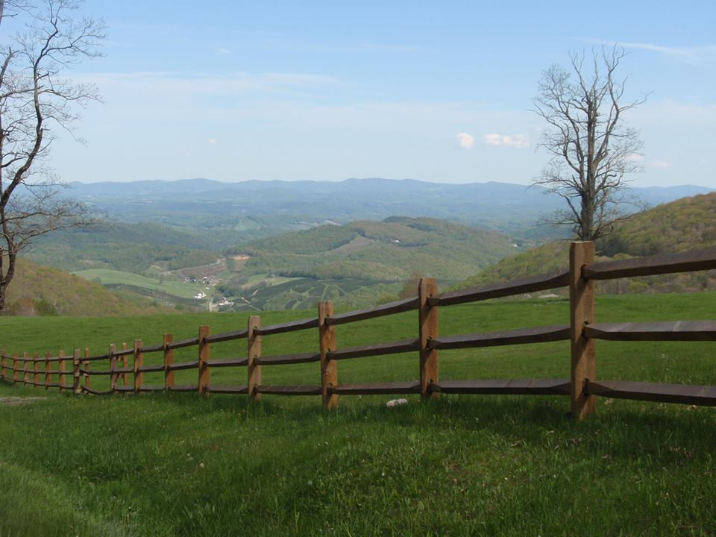
Down in the Valley

Down in the valley; valley so low,
Hang your head over, heard the wind blow.
Hear the wind blow, dear, hear the wind blow.
Hang your head over, hear the wind blow.

Roses love sunshine, violets love dew.
Angels in Heaven know I love you.
Know I love you, dear, know I love you.
Angels in Heaven know I love you.

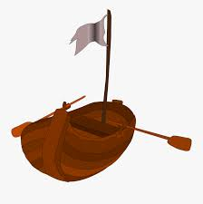
Michael, Row the Boat Ashore

Michael, row the boat ashore, hallelujah!
Michael, row the boat ashore, hallelujah!

Sister help to trim the sails, hallelujah!
Sister help to trim the sails, hallelujah!

The River Jordan is chilly and cold, Hallelujah!
It chills the body, but not the soul, Hallelujah!

The river is deep and the river is wide, Hallelujah!
Milk and honey on the other side, Hallelujah!

Swing Low, Sweet Chariot

Swing low, sweet chariot, coming for the carry me home.
Swing low, sweet chariot, coming for the carry me home.

I looked over Jordan, and what did I see, coming for the carry me home?
A band of angels, coming after me; coming for the carry me home.

If you get there before I do; coming for the carry me home,
Tell all my friends I’m coming too; coming for the carry me home.

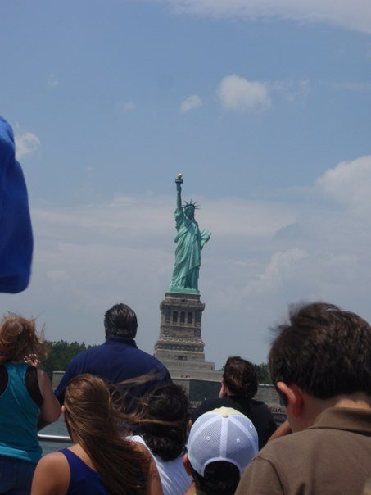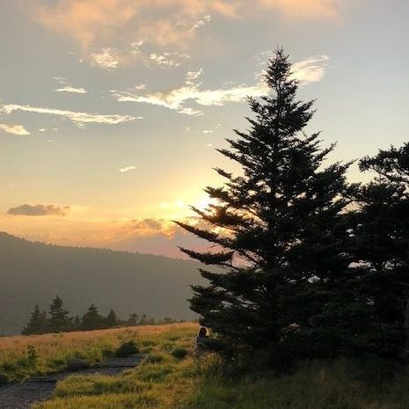
This Land is Your Land

This land is your land, this land is my land, from California to the New York island.
From the redwood forest to the gulfstream waters, this land was made for you and me.

As I was walking that ribbon of highway
I saw above me that endless skyway,
I saw below me that golden valley.
This land was made for you and me.

I roamed and rambled, and I've followed my footsteps
To the sparkling sands of her diamond deserts,
And all around me a voice was sounding,
‘This land was made for you and me.’

When the sun come shining, then I was strolling,
And the wheat fields waving and the dust clouds rolling,
A voice was chanting as the fog was lifting,
‘This land was made for you and me.’

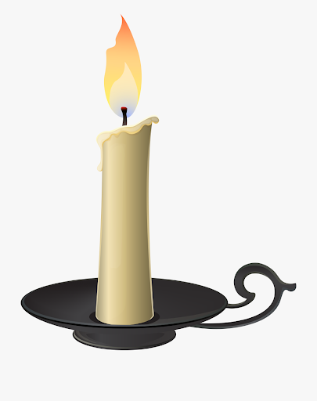
This Little Light of Mine

This little light of mine, I’m gonna let it shine!
This little light of mine, I’m gonna let it shine!
This little light of mine, I’m gonna let it shine!
Let it shine, let it shine, let it shine!

Hide it under a bushel? No! I’m gonna let it shine! (3 times)
Let it shine, let it shine, let it shine!

Won’t let Satan (blow) it out! I’m gonna let it shine! (3 times)
Let it shine, let it shine, let it shine!

Shine all over this great, big world! I’m gonna let it shine! (3 times)
Let it shine, let it shine, let it shine!

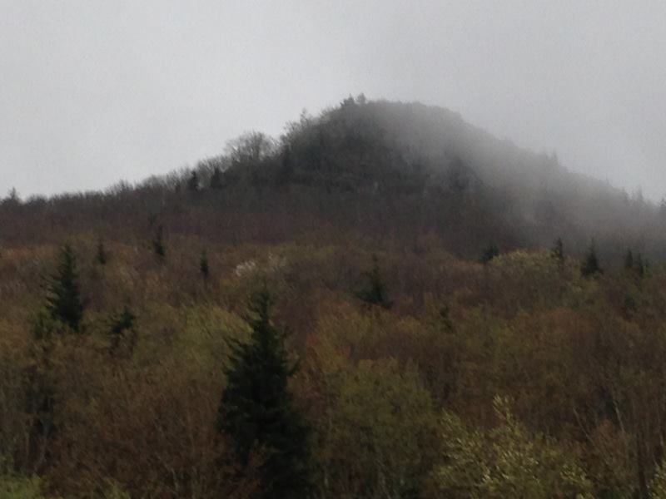
On Top of Old Smokey

On top of old Smokey, all covered with snow
I lost my dear lover by courting too slow.

For courting is pleasure, and parting is grief.
And a false-hearted lover is worse than a thief.

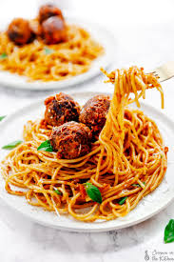

On top of spaghetti all covered with cheese
I lost my poor meatball when somebody sneezed.

It rolled off the table, and onto the floor.
And then my poor meatball rolled out of the door.

It rolled down the sidewalk and under a bush.
And now my poor meatball is nothing but mush.

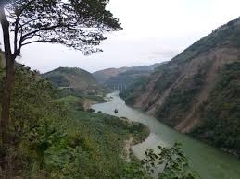
Red River Valley

From this valley they say you are going.
We will miss your bright eyes and sweet smile,
For they say you are taking that sunshine,
That has brightened our pathway a while.

Come and sit by my side if you love me,
Do not hasten to bid me ‘adieu’,
But remember that Red River Valley,
And the cowboy who loved you so true. (insert coyote howl!)

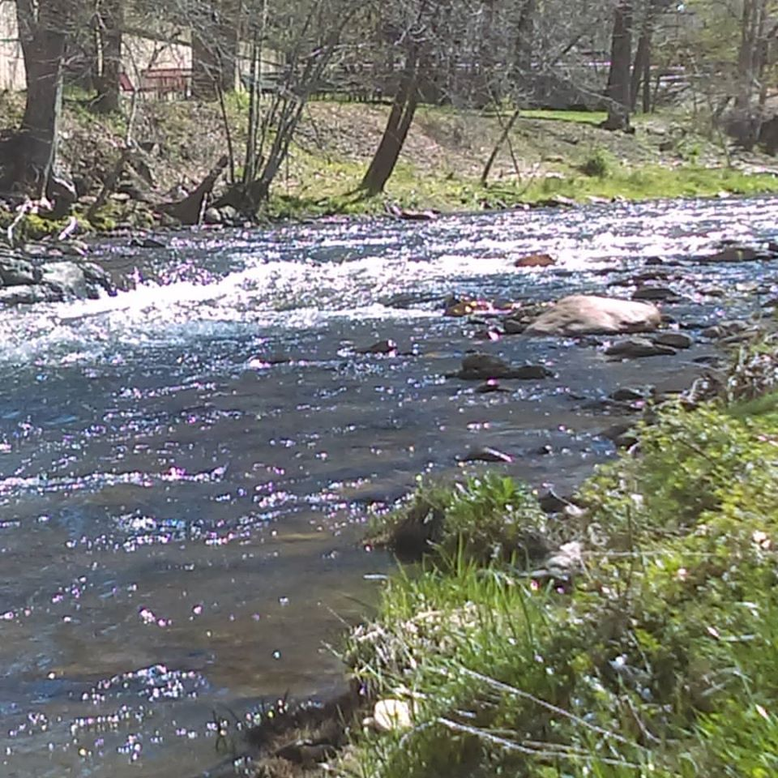

Wade in the Water

Wade in the water. Wade in the water, children.
Wade in the water. God’s gonna trouble the water.

See that band all dressed in white? God’s gonna trouble the water.
The leader looks like the Israelite. God’s gonna trouble the water

See that band all dressed in red? God’s gonna trouble the water.
It must be the band that Moses led. God’s gonna trouble the water.

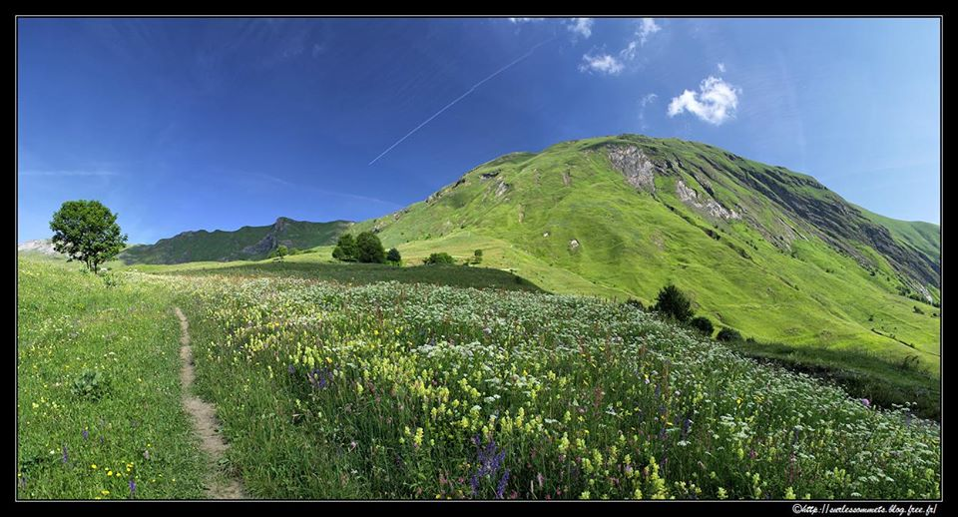

She’ll Be Comin’ ‘Round the Mountain

She’ll be comin’ ‘round the mountain when she comes.
She’ll be comin’ ‘round the mountain when she comes.
She’ll be comin’ ‘round the mountain, she’ll be comin’ ‘round the mountain,
She’ll be comin’ ‘round the mountain when she comes.

She’ll be…
…driving six white horses
…riding fuzzy poodles
…riding three coyotes
…riding German shepherds
…wearing striped (or pink) pajamas
…wearing pretty facemasks
…swimming in Purell™
…walking Gatsby Carr

She will
…bring us toilet paper
…bring us a vaccine
…bring us gloves and Lysol™
…bring her pet flamingo
…schedule a Zoom™ meeting

We will
…need hand sanitizer
…all have chicken and dumplings
…all eat quinoa gloop (or quinoa popcorn, or green lentils if Mr. Yoder forgets the quinoa)
…let her sing in choir
…lock her in the barn

